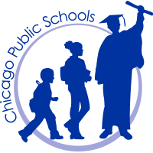
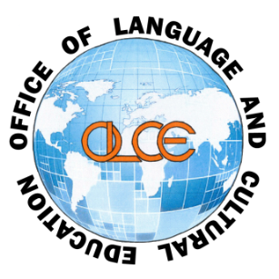
Office of Language and Cultural Education
42 West Madison, 2nd Floor • Chicago, IL 60602
Telephone: (773) 553-1930 • Fax: (773) 553-193

Chicago Public Schools & the University of Chicago
SUMMER 2016 ARABIC & CHINESE STARTALK PROGRAMS
Once again, Chicago Public Schools has been awarded the STARTALK grant from the federal government to implement an Arabic and Chinese Language Institute in collaboration with the University of Chicago this summer! Your son or daughter may be eligible to apply for this program, due to his or her current enrollment in Arabic Year/Level 1 or 2 or Chinese Year/Level 2 or 3.
The goal of the CPS STARTALK program is to encourage students to go beyond the two-year state requirement for high school World Language study and to increase their language proficiency to the next level of Arabic or Chinese. Participants will attend classes taught by University of Chicago faculty Monday-Friday from 10:00 a.m.-3:00 p.m. from June 27 - July 22, 2016.
An informational STARTALK meeting will be held for interested students, parents & teachers on:
Saturday, March 12, 2016
10:30 a.m.-11:30 a.m.
Confucius Institute, Room 106
Walter Payton High School, 1034 N. Wells St.
(Street parking available)
The STARTALK application process is highly competitive and only 30 CPS students will be selected by the University of Chicago for participation: 15 in Arabic and 15 in Chinese. Students who qualify are eligible to apply. Preference will be given to students who have not participated in the CPS STARTALK Summer Program before. Online applications will be available after March 12 on the University of Chicago Summer Session website (summer.uchicago.edu/startalk). Applications will not be accepted after 4:30 p.m. on Friday, May 9.
We hope you will encourage your son or daughter to apply for the summer’s STARTALK Arabic or Chinese program to reinforce and enhance their language proficiency through daily interaction with renowned University of Chicago Arabic and Chinese instructors and fun cultural activities. Please do not hesitate to contact Fabiola Fadda-Ginski at fmginski@cps.edu if you have any questions or concerns. Thank you!

